1. Setup Minikube in your local machine.

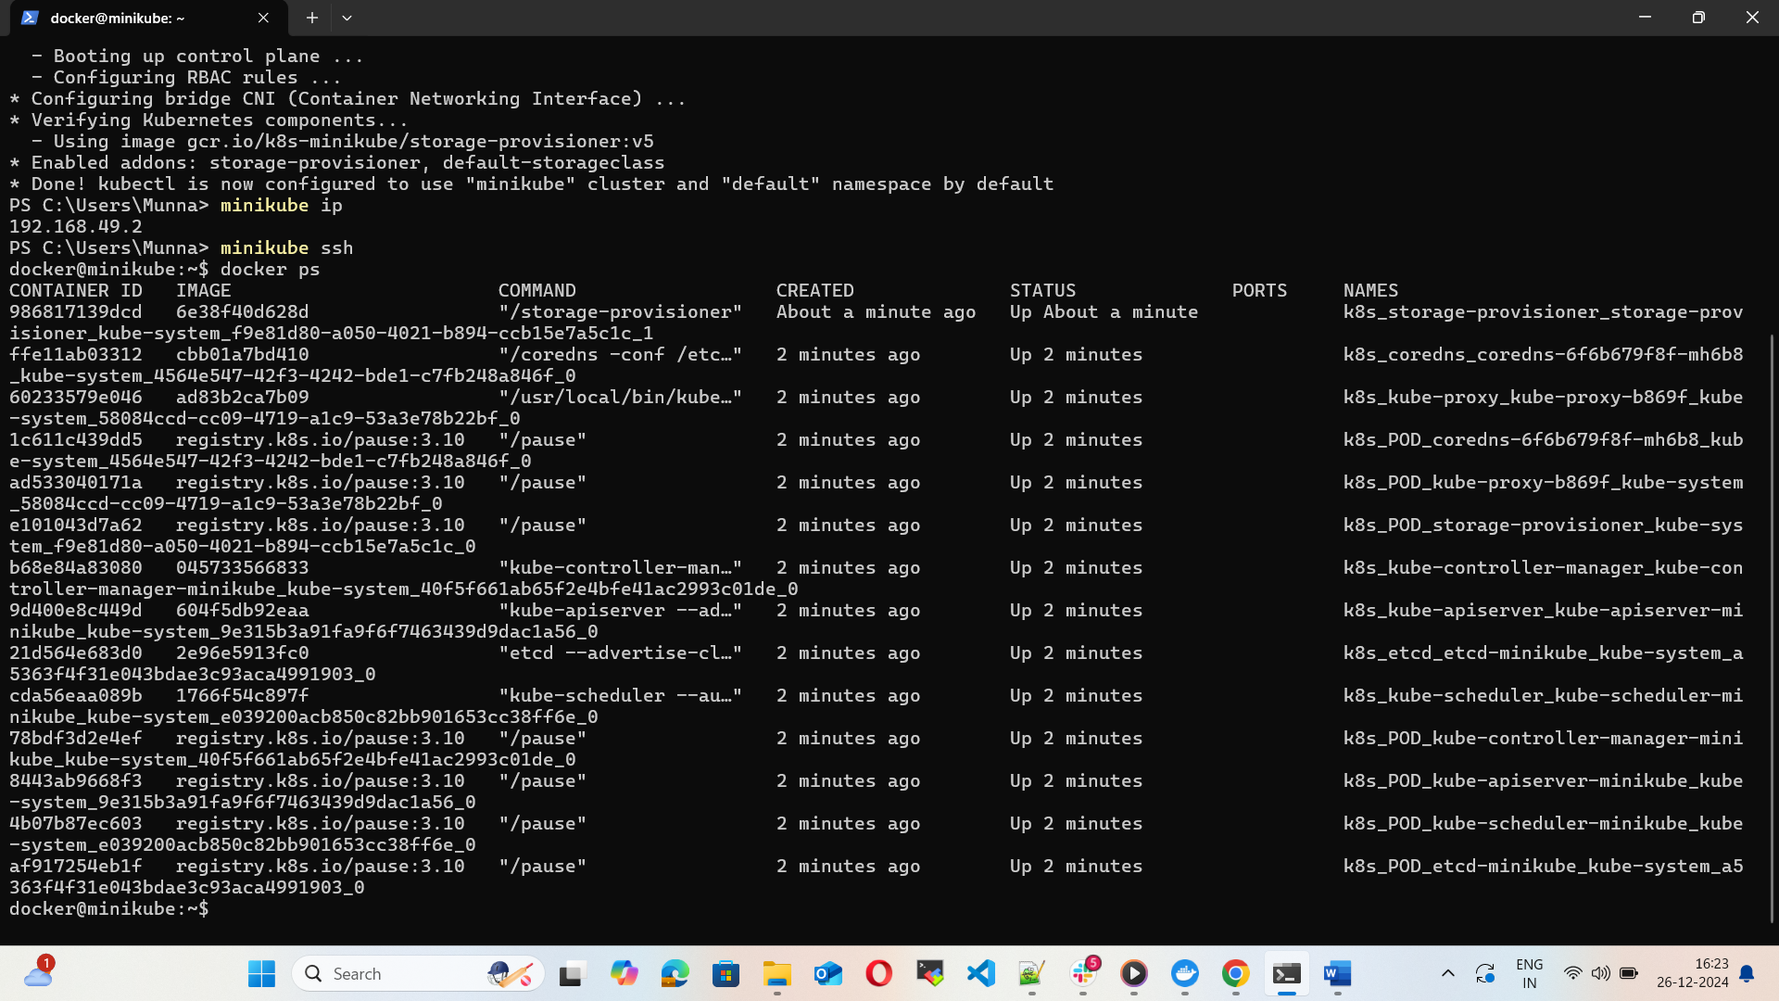

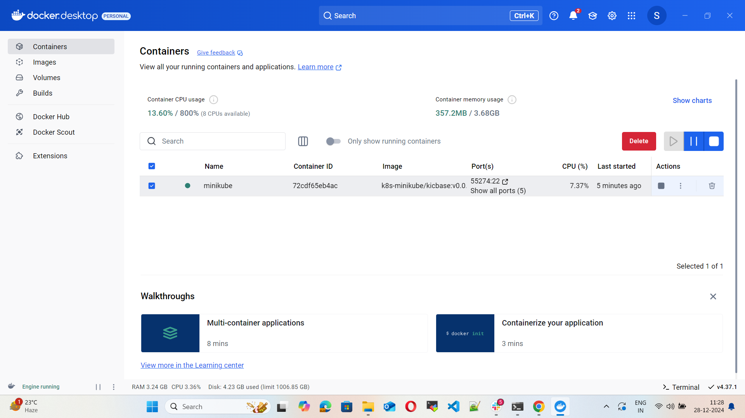

1. Setup k8s master and two worker nodes on ubuntu.

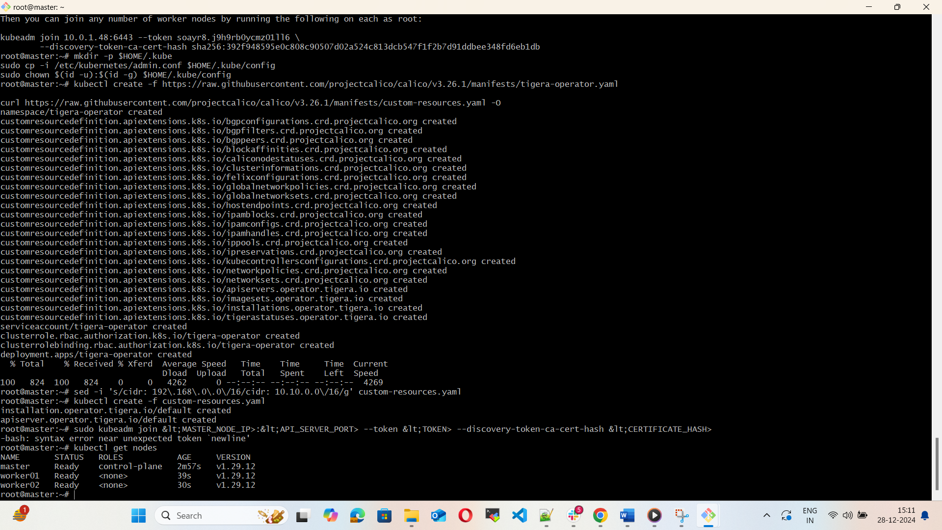

1. Run one nginx pod.

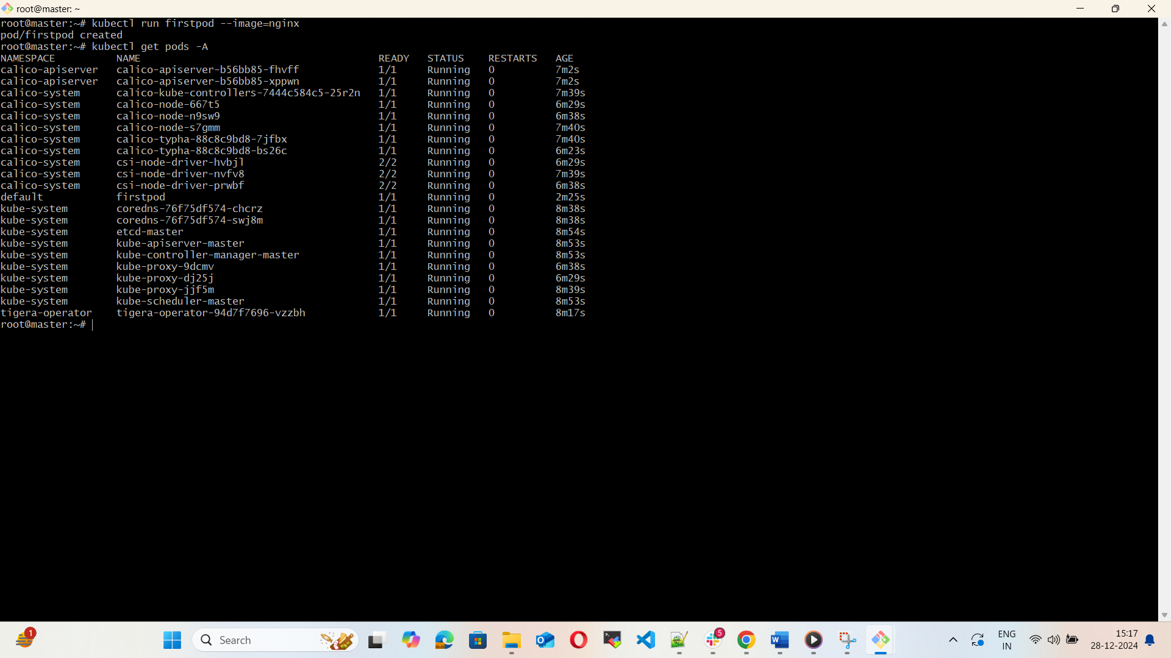

1. Mug up Master and slave components on k8s.

For Master and worker nodes we have few components that are  
Api server  
Etcd  
Scheduler  
Controller manager  
Container runtime  
Kubelet  
KubeProxy